to: Agnes, Degu
cc: Bianca, Norma, Edine
from: Roel
date: 29th June 2025
subject: update on fitting EndTB model to VNM data
=========================================================

Methods

- natural history model as shown in appendix below
- sex and age dependent progression
sex (pE=0.34 for female, 0 for male) and age dependent progression (for age group 0 thru 14 vs 15+) from Lf, Ls and R to Ds
<treatment.matrix name="LfLsRDs">
<transition from="Lf" to="Ds" rate="(1-pE)*max(0.0696,theta*j1)"/>
<transition from="Ls" to="Ds" rate="(1-pE)*max(0.000135,sigma*j2)"/>
<transition from="R" to="Ds" rate="(1-pE)*max(0.01,rho*j3)"/>
</treatment.matrix>
- age (and time) dependent treatment initiation (for 0-14, 15-24, 25+):
<treatment.matrix name="init">
<transition from="Dc" to="T" rate="eta*j4"/>
<multiplier name="etamul" times="1959:2019" values="1/(1+exp(-sh*(x-midx)))"/>
</treatment.matrix>
- sex dependent treatment success:
<TB.parameter SES.stage="female" name="sfr" value="0.97485822"/>
<TB.parameter SES.stage="male" name="sfr" value="0.70472"/>
- sex dependent transmission (through pE which is 0 for male, 0.34 for female):
<transmission.matrix Mtb-strain="drugsens">
<transition from="Un" to="Lf" rate="(1-pE)*pT"/>
<transition from="Uc" to="Lf" rate="(1-pE)*pT*(1-pR*pC)"/>
<transition from="Ls" to="Lf" rate="(1-pE)*pT*(1-pR)"/>
<transition from="R" to="Ds" rate="(1-pE)*pT*(max(0.0696,j1*theta)/(max(0.0696,j1*theta)+omega))*(1-pR)"/>
<multiplier name="beta" times="1800,2020" values="1,1"/>
</transmission.matrix>
Not yet taken into account: assortative mixing by sex (in combination with age group mixing).

- data used
  - 2000 thru 2015: TB notifications (all) by year
  - 1996 thru 2015: TB notifications (male) by year
  - 1996 thru 2015: TB notifications (female) by year
  - 2000 thru 2023 estimated TB incidence (all) by year
  - 2000 thru 2023 TB deaths (all) by year
  - 2007 prevalence estimates by age group (0-99, 15-24, 25-34, 35-44, 45-54, 55-64, 65+) and by sex for age 15-99 (all, male, female)
  - 2018 prevalence estimates by age group (0-99, 15-24, 25-34, 35-44, 45-54, 55-64, 65+) and by sex for age 15-99 (all, male, female)
  - 2016 thru 2023 notifications by sex and age group (0-14,15-24,25-34,35-44,45-54,55-64,65+)

Results

[the plots below, lines (in blue) are data (if available with confidence interval), model results are data points in red]

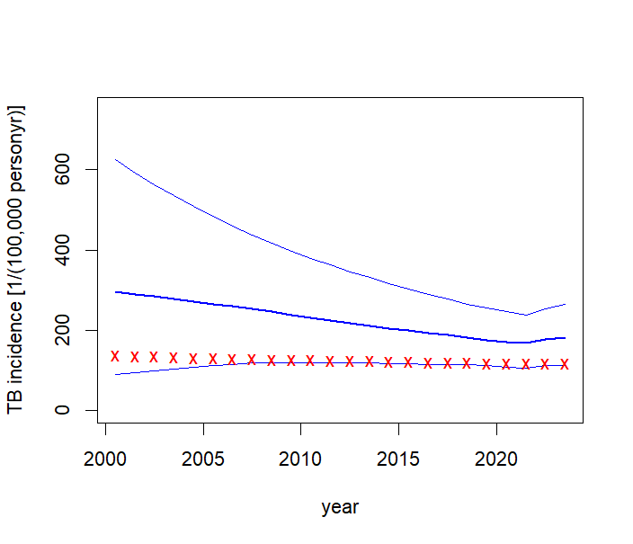

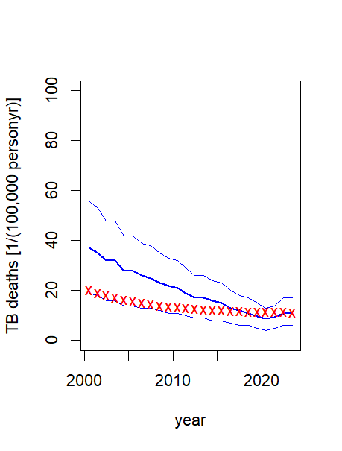
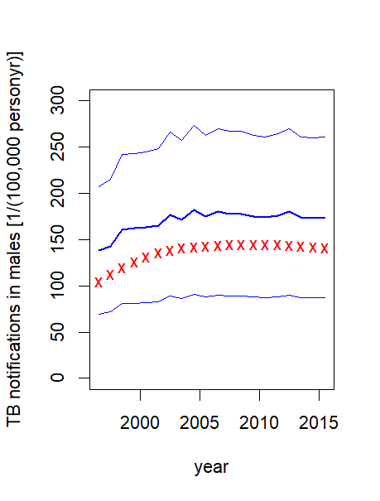
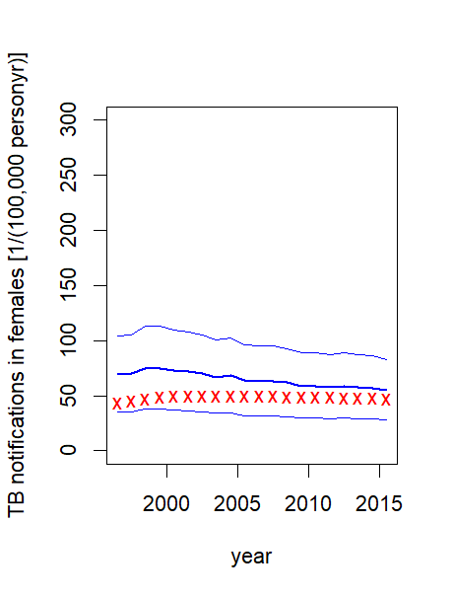

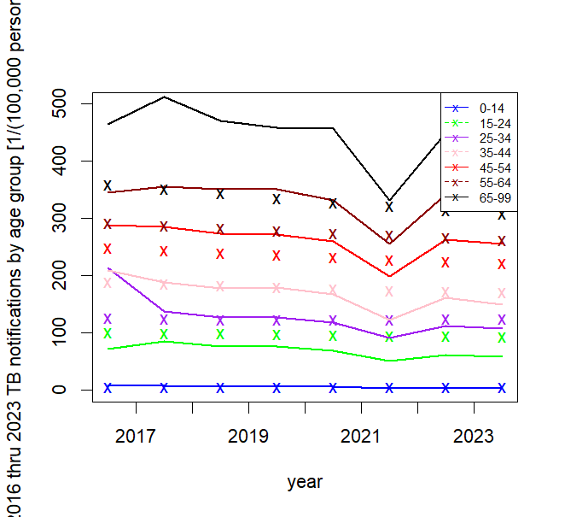
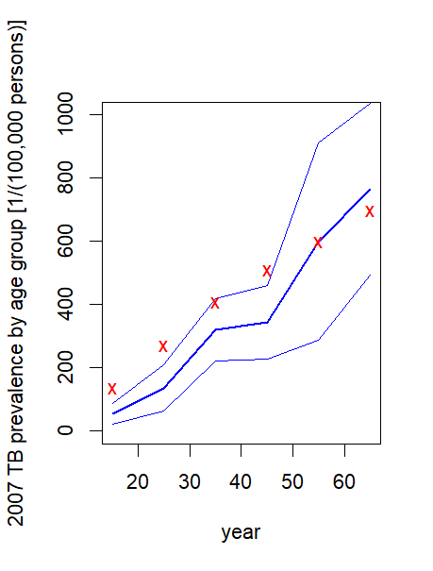
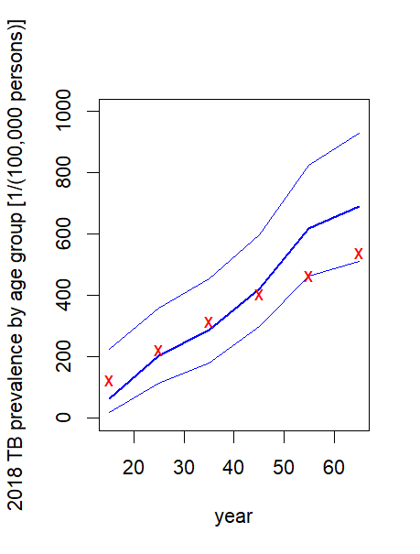
Discussion

The model fits 231 out 239 target values (i.e. are within the (estimated) confidence interval).
TO DO:
- add assortative mixing by sex (in addition to age group mixing)
- review and discuss parameter values
- improve fit (?)
- add interventions such as TPT
- compare with alternative natural history models

Technical appendix
Natural history model from paper by Clark et al on TB vaccine impact in LMIC countries:
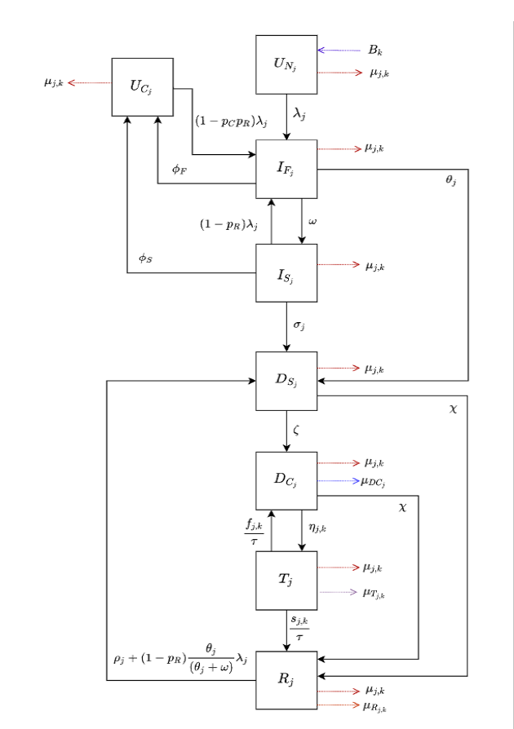
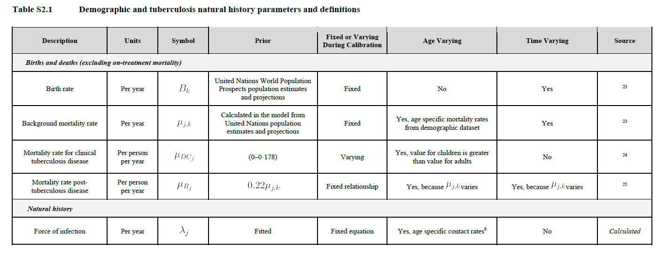

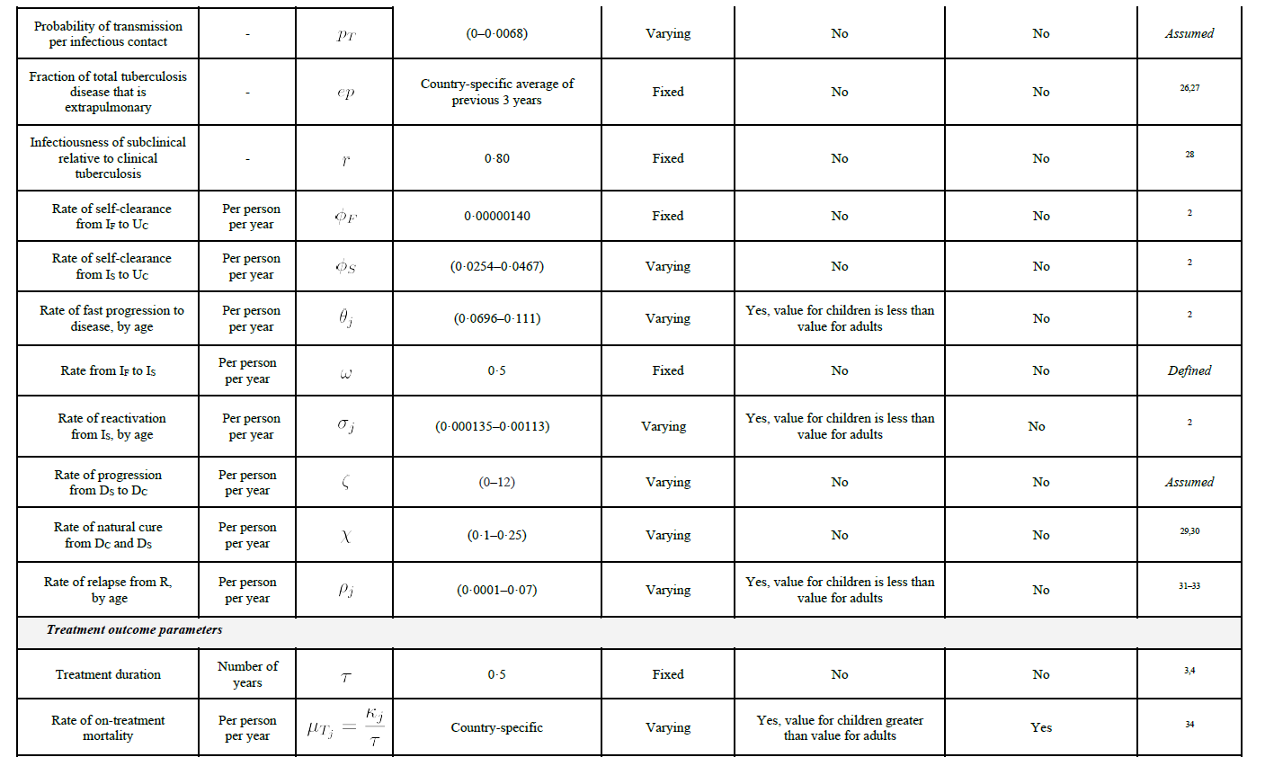

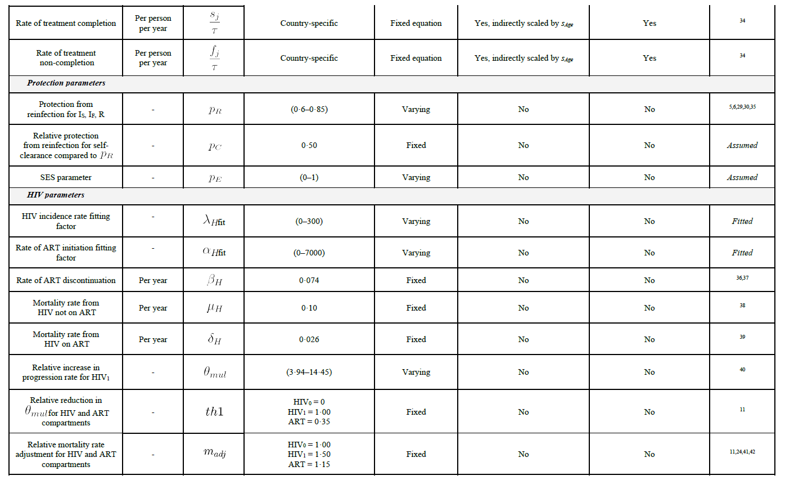

From the paper on subclinical TB by Jon Emery et al



